INTERNSHIP POSITION AT INTERNSAVY

(ABISHA . K )

INTERN TASK – DATASCIENCE

TASK – 1

Use classification technique for prediction of Graduate Admissions from an Indian perspective

Dataset link :

[Graduate Admission 2 | Kaggle](https://www.kaggle.com/datasets/mohansacharya/graduate-admissions)

CODE :

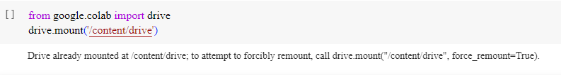

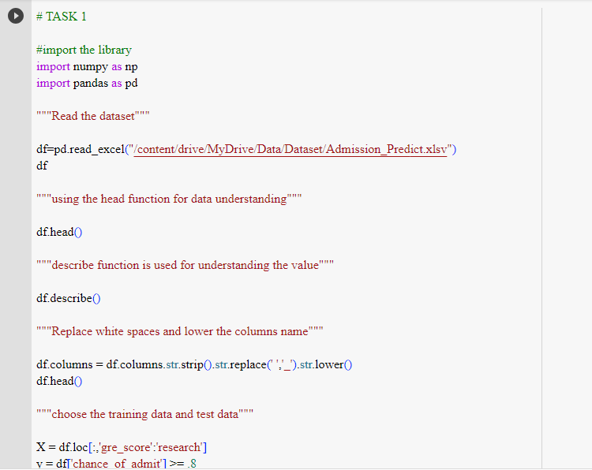

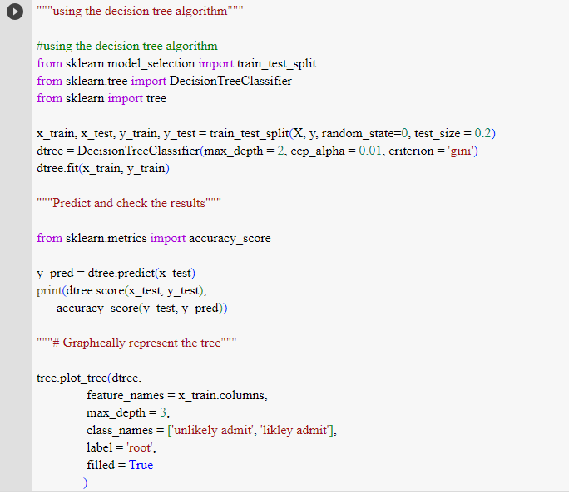

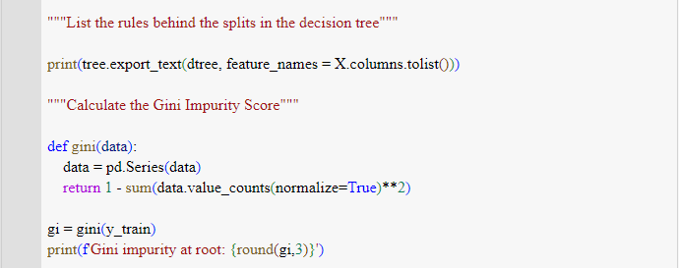

OUTPUT :

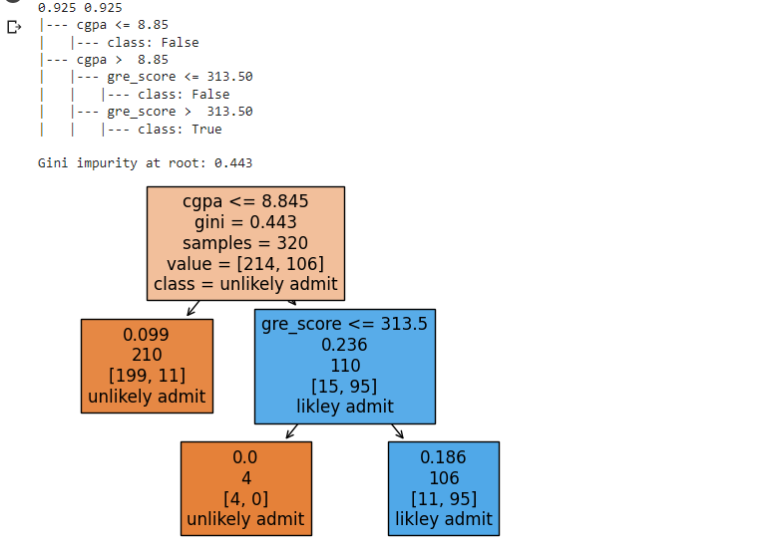

TASK – 2

Use Clustering Techniques for the any customer dataset using machine learning

Dataset link :

[Mall_Customers | Kaggle](https://www.kaggle.com/datasets/shwetabh123/mall-customers)

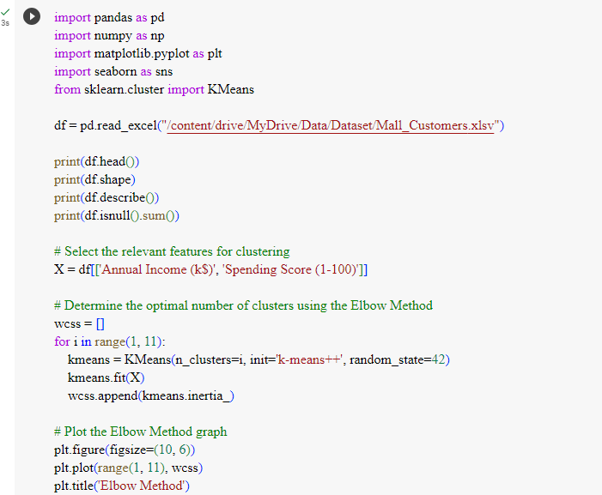

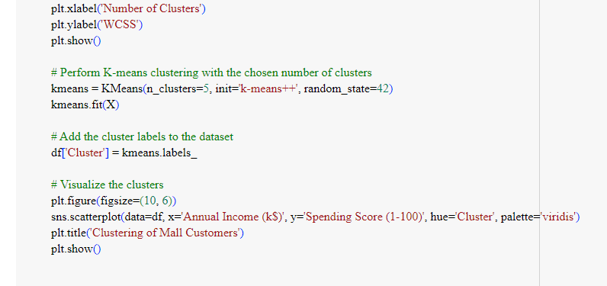

OUTPUT :

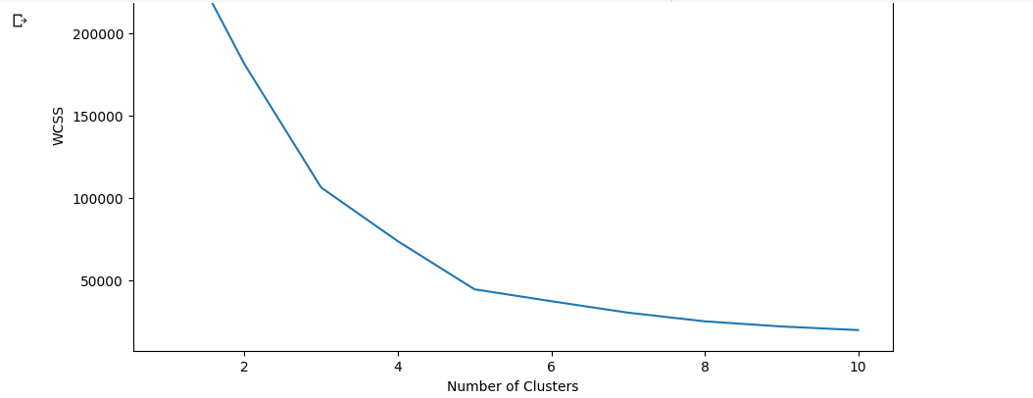

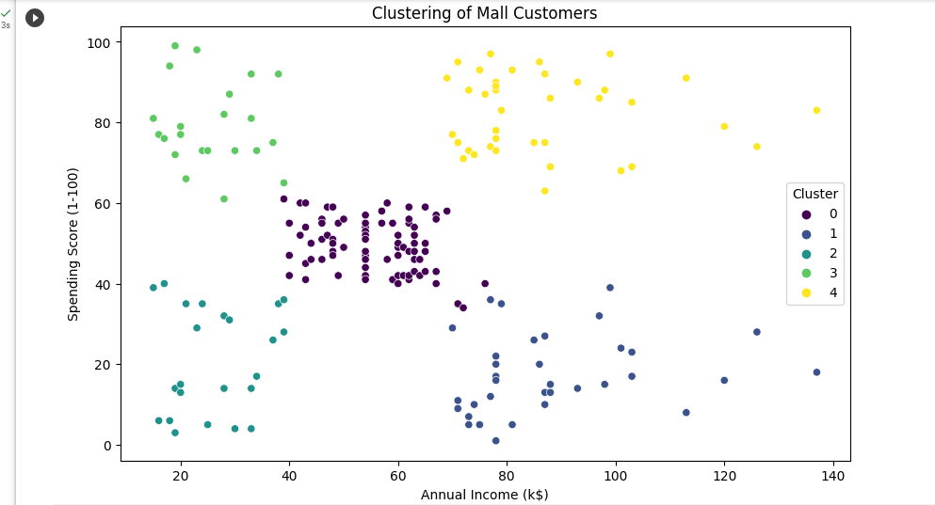

TASK -3

Customer Segmentation Analysis with Python

Data set link :

[Mall Customer Segmentation Data | Kaggle](https://www.kaggle.com/datasets/vjchoudhary7/customer-segmentation-tutorial-in-python)

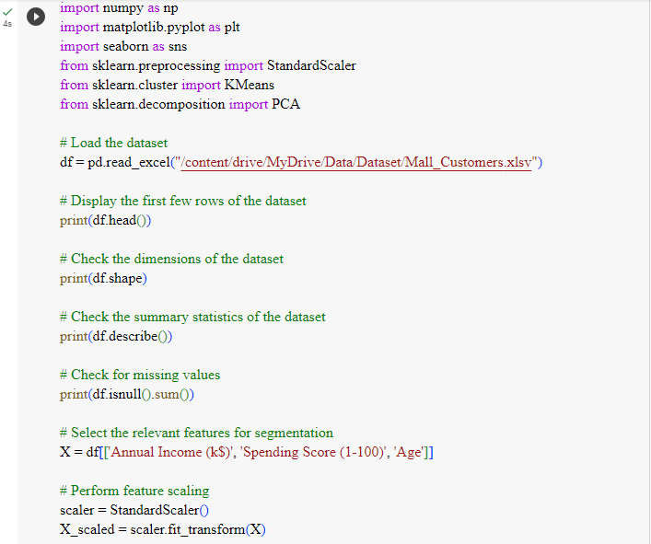

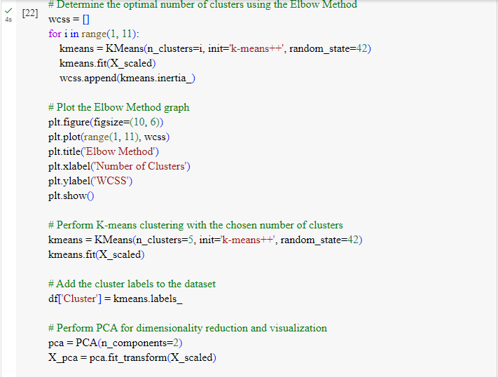

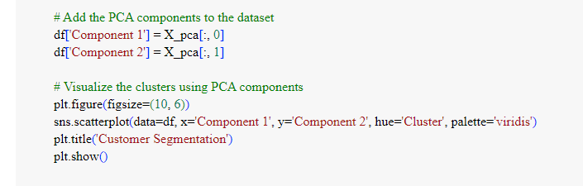

OUTPUT :

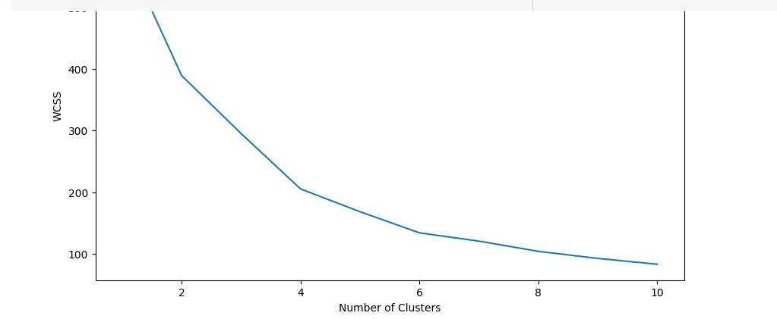

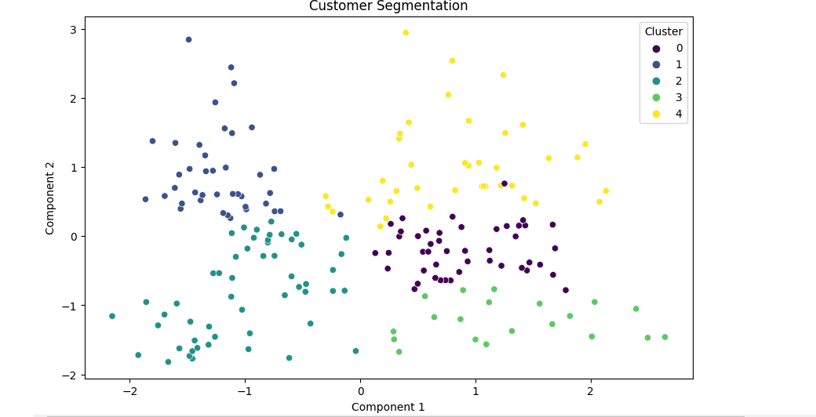

TASK – 4

Cricket Player Performance Prediction using machine learning

Dataset link :

[Cricket World Cup 2019 Players Data | Kaggle](https://www.kaggle.com/datasets/saivamshi/cricket-world-cup-2019-players-data)

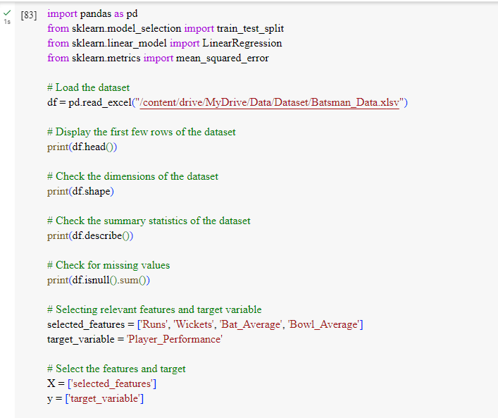

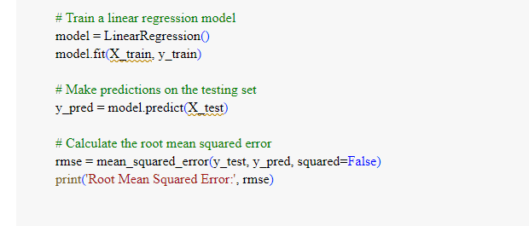

OUTPUT :

